UNIVERSITY OF MISSOURI
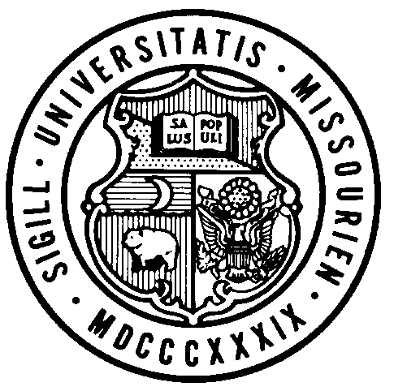
BOARD OF CURATORS
MEETING AGENDA

June 20-21, 2019
Columbia, Missouri

All public session meetings to be held in North 201 A and B of Memorial Union, 518 Hitt Street, University of Missouri – Columbia campus, Columbia, Missouri unless otherwise noted.

Board Committee meetings were held June 11 and 12, 2019 in conjunction with the June 20-21, 2019 Board meeting.

THURSDAY, JUNE 20, 2019

BOARD OF CURATORS MEETING – PUBLIC SESSION

9:00 – 10:00 A.M. Intercampus Faculty Council Roundtable by Invitation with the Board of Curators and President
Location: North 201 C, Memorial Union

10:00 A.M. Call to Order

General Business

Information
- University of Missouri Board Chair’s Report
- University of Missouri System President’s Report
- Student Representative to the Board of Curator’s Report

Information
- Review Consent Agenda

Consent Agenda

Action
- Minutes, April 11, 2019 Board of Curators Meeting
- Minutes, April 11, 2019 Board of Curators Committee Meetings
- Minutes, March 27, 2019 Board of Curators Special Meeting
- Minutes, May 15, 2019 Board of Curators Special Meeting and Finance Committee Meeting
- Degrees, Summer Semester 2019 for all campuses
- Project Approval, MU Gas Turbine Building – Chilled Water Plant Addition
- Project Approval, MU Library Depository – Construct Phase 2

10:40 A.M. FINANCE CHAIR REPORT
(Curators Brncic, Chatman, Layman, Steelman)

Finance Committee Chair Brncic to provide an overview of action items.

Action
- UM Fiscal Year 2020 Operating Budget and Five-Year Financial Plan
- UM Fiscal Year 2021 State Appropriations Request for Operations
- UM Fiscal Year 2021 State Capital Appropriations Request

11:05 A.M. COMPENSATION AND HUMAN RESOURCES COMMITTEE MEETING
(Curators Snowden, Brncic, Chatman, Farmer)

Action
- Resolution for Executive Session of the Compensation and Human Resources Committee

11:10 A.M. ACADEMIC, STUDENT AFFAIRS AND RESEARCH AND ECONOMIC DEVELOPMENT CHAIR REPORT
(Curators Chatman, Layman, Phillips, Snowden)

Academic, Student Affairs and Research and Economic Development Committee Chair Chatman to provide an overview of action items.

Action
- New Degree Proposal, Bachelors of Arts in Constitutional Democracy, MU (Justin Dyer)
- New Degree Proposal, Masters of Arts in Atlantic History and Politics, MU (Jay Sexton)

11:20 A.M. AUDIT COMMITTEE MEETING
(Curators Layman, Brncic, Farmer, Graham)

Audit Committee Chair Layman to provide time for discussion of committee business.

Information
- Internal Audit and Consulting Annual Report, UM (Michelle Piranio)

Action
- Fiscal Year 2020 Risk Assessment and Internal Audit Plan, UM (Michelle Piranio)

11:40 A.M. HEALTH AFFAIRS CHAIR REPORT
(Curators Graham, Phillips, Snowden, Steelman, Mr. Ashworth)

Health Affairs Committee Chair Graham to provide an overview of information and action items.

Information
- Quarterly Compliance Report, MU Health (Jennifer May)
- Quarterly Financial Report, MU Health (Mike Blair)
- UM Healthcare Annual Report (Jonathan Curtright and Interim Dean Zweig)

Action
- Minutes Approval, April 1, 2019 Health Affairs Committee Meeting

11:55 A.M. Break

12:00 P.M. Luncheon by Invitation for the Board of Curators, President, University of Missouri System Leaders and the Intercampus Staff Advisory Council
Location: North 214 B and C, Memorial Union

1:15 P.M. PUBLIC SESSION

General Business

Information
- Transformation Update and Information Technology Annual Report (Gary Allen)

Action
- Resolution, Retiring Vice President for Information Technology - Gary Allen, DVM, Ph.D.
- Resolution, Chief Diversity Officer and Vice Chancellor for Inclusion, Diversity and Equity – Kevin G. McDonald, J.D., Ed.D.

Information
- University of Missouri – Columbia Student Presentations -
Topic: Beyond the Lab – Mizzou Students Contribute to the States Wellbeing (Nicketa Coombs, M.Ed., Alek Willsey, PhD Candidate and Jesus Oropeza)
- Good and Welfare of the Board

Action
- Resolution for Executive Session of the Board of Curators Meeting, June 20-21, 2019

2:15 P.M. Press Conference with Board of Curators Chair and UM System President (time is approximate)
Location: North 214 A, Memorial Union

2:20 P.M. BOARD OF CURATORS COMPENSATION AND HUMAN RESOURCES COMMITTEE MEETING - EXECUTIVE SESSION (time is approximate)
Location: North 204, Memorial Union

The Compensation and Human Resources Committee will hold an executive session of the June 20-21, 2019 meeting, pursuant to Section 610.021(1), 610.021(3), 610.021(12), 610.021(13) and 610.021(17) RSMo, for consideration of certain confidential or privileged communications with university counsel, contract, personnel items and confidential or privileged communications between a public governmental body and its auditor, as authorized by law and upon approval by resolution of the Compensation and Human Resources Committee.

3:30 P.M. BOARD OF CURATORS MEETING-EXECUTIVE SESSION (time is approximate)
Location: North 204, Memorial Union

The Board of Curators will hold an executive session of the June 20-21, 2019 meeting, pursuant to Sections 610.021(1), 610.021(2), 610.021(3), 610.021(12), 610.021(13) and 610.021(14) RSMo, for consideration of certain confidential or privileged communications with University Counsel, personnel, property, litigation, contract items, and records protected by law, all as authorized by law and upon approval by resolution of the Board of Curators.

5:50 P.M. Recess Board of Curators Meeting

6:00 P.M. Reception by invitation for Board of Curators, President and University of Missouri System leaders
Hosted by: Chancellor Alex Cartwright
Location: Stotler Lounge, Memorial Union

FRIDAY, JUNE 21, 2019

BOARD OF CURATORS MEETING – PUBLIC SESSION

8:00 A.M. Call to Order

General Business

Information
- Collegiate Student Mental Health

Action
- Adjourn Board of Curators Meeting and Committee Meetings, June 20-21, 2019

11:00 A.M. Event: Official Launch of a Statewide Precision Health Initiative and Groundbreaking of its Anchoring Research Facility
Location: Building Site on the Corner of Virginia Avenue and Hospital Drive, University of Missouri - Columbia

Upcoming meetings of the Board of Curators:
September 26, 2019 University of Missouri – Kansas City
November 21, 2019 University of Missouri – St. Louis

